|  |
| --- |
| EU Children's Participation Platform  Findings from the consultation with children on democracy and voting |
| A report submitted by ICF S.A.  in association with  SOS Children's Villages, Save the Children, Risk & Policy Analysts Ltd. Laura Lundy, Cath Larkins  Date: 19 July 2024 |
| ICF S.A.  Avenue Marnix 17 Brussels B-1000 Belgium  T +32 (0) 2 275 01 00  www.icf.com |

Contents

Executive summary i

1 Introduction 3

Consultation theme, policy context, and aims and objectives 3

2 Children are generally aware and participate in a wide range of participation opportunities 4

2.1 Children think participation includes being informed, being heard and voting 4

2.2 Children participate in a range of participatory spaces 4

2.3 How do children participate and how would they want to participate 5

2.4 Spaces created for and by children give them opportunities to influence decisions 8

2.5 Children appreciate when their participation makes a difference 9

2.6 Children’s recommendations 12

3 Children care about and want to influence issues directly impacting them and society 13

3.1 Children care about issues that have direct impact on their lives 13

3.2 Children want to influence decisions and make their voices heard 15

3.3 Children would like to influence decisions but only one in four children have ever influenced any decisions 17

3.4 Children’s recommendations 20

4 Children are informed by social media, their peers and family 21

4.1 Children find information about issues they care about and learn about opportunities to participate from a variety of sources 21

4.2 Children want more information about opportunities to participate 24

4.3 Children want to be informed about how they have influenced a decision 24

4.4 Children are aware of misinformation and take precautions against it 27

4.5 Children’s recommendations 30

5 Children want more education about voting 32

5.1 Knowledge of voting 32

5.2 Children expressed mixed views on whether the voting age be lowered 32

5.3 Children expressed a willingness to vote if the voting age was lowered 37

5.4 Children’s recommendations 38

6 Children’s priorities 39

Annex 1 Consultation methodology and characteristics of children participating in the consultation activities 40

Executive summary

This report presents the **findings from the consultation with children on democracy and voting**. It was conducted under the **EU Children’s Participation Platform**. Children’s views will feed into a child-friendly document – ‘a mini toolkit on democratic participation and voting’ – and will also aid the EU in better understanding and supporting children’s participation in decision-making processes across Europe.

Between March and May 2024, **2,071 children and some young people[1] from 23 countries of the European Union and EU citizens living abroad participated in the consultations (1,921 in the online survey, 31 in interviews and 122 in focus groups)**.

The consultation was guided by the Lundy model[2] of child participation and children were actively involved in designing the consultation process and content.

**Key findings:**

* Children pointed that they are **generally aware of and take part** in a wide range of participation opportunities. However, **many children still do not know how** they can become involved in democratic processes.
* When they take part, **children’s participation is often limited to spaces ‘for children’ and at local level**, like schools and organisations working with and delivering services for children and young people in local communities. Children would like to have opportunities to have a say and influence decisions in ‘adult spaces’, notably at national and EU level. **Children often or usually experience positive feelings related to their participation**, such as a feeling of influence, fulfilment and pride. They also **value receiving feedback** after taking part. However, children are **often not informed whether and how their input was picked up by adults, and how it was taken into account or not**. Not knowing and not seeing whether and how their ideas are translated into concrete actions **made children feel frustrated and less likely to want to take part again**.
* **Children care about issues that have a direct impact on their lives**, families, schools and local communities. They also expressed interest in wider aspects such as social and civic issues, socio-economic inequalities, geopolitical conflicts, sustainability and climate change. **When participating, they take part because the issue is important to them, and has a direct impact on children and society**.
* **Children use different sources of information to learn about opportunities to participate**, including families, friends, schools, local groups, the Internet and social media. They called for schools to have a greater role in sharing information. Receiving information before taking part in activities helps children to prepare and participate effectively. However, **being informed about an activity before taking part is still not a usual practice and experience for many children**.
* **Children are aware of misinformation**. They shared specific examples about steps they take to check the reliability of sources of information. Some children are also actively involved in combating misinformation. They called for more support from adults to better tackle fake news and to have access to more age appropriate and understandable information.
* **Children** have knowledge of voting but **expressed mixed views on whether the voting age should be lowered**. Children who support lowering the voting age argued that this would increase political representation and facilitate their political engagement from an earlier age. Children against the lowering of the voting age suggested that many children lack the maturity needed to vote and their votes could be easily influenced by others. **All children agreed that education is an important factor for making democratic choices and asked for more support, training and awareness raising to help them become more informed and engaged citizens**.

**Key recommendations from children:**

* **Educate** children and adults **about democratic values and about the value of children’s participation**. Children also asked for more education **about voting and democratic institutions and processes**.
* Provide children with **better information** about how, when and where they can participate. Children asked for information to be provided in an accessible, inclusive, age appropriate and easy to understand way as participation is a practice that must be learned from a young age.
* **Create more safe and inclusive spaces** where children can participate and express their opinions freely without fear of judgement.
* **Ensure that children are involved in more democratic processes and spaces** by reforminggovernance on the participation of children in schools and community spaces and creating more forums for exchanges on social and civic issues, at local but also national and EU level.
* **Acknowledge and take into account** children’s views and suggestions across a range of decisions, and provide feedback on **how their input had an impact (or not) on decisions**.
* **Create more guidance on online misinformation** and **equip** children and adults **with the skills and tools to take precautions against it.**

# Introduction

This report presents findings from the second consultation with children conducted for the EU Children’s Participation Platform. It has the following structure:

Section 2, 3, 4, and 5 report on the consultation findings and key recommendations from children;

Section 6 reports on the collated key recommendations from children

Annex 1 presents the consultation methodology and the characteristics of children participating in the consultation activities;

Consultation theme, policy context, and aims and objectives

This second consultation of the EU Children’s Participation Platform[3] focused on **Democracy and Voting.** It ran from March to May 2024. In total, 2,074 children and young people[4] from 23 countries of the European Union and EU citizens living abroad participated in the consultations (1,921 in the online survey, 31 in interviews and 122 in focus groups). The largest number of children taking part in this consultation was from Romania and Croatia cumulatively contributing to nearly 80% of all consulted children[5].

Children taking part in the EU Children’s Participation Platform activities in 2023 asked the Platform to focus on child participation in decision-making and voting. The topic was linked with the European Parliament elections that took place in June 2024. Creating opportunities for children to discuss openly about how democracy and voting work may have an impact on them as active citizens and future voters and candidates for elections. The results of this child consultation contributed to a child friendly document: ‘a mini toolkit on democratic participation and voting’. The results and feedback from children will also aid the EU in better understanding and supporting children's participation in decision-making processes across Europe.

# Children are generally aware and participate in a wide range of participation opportunities

## Children think participation includes being informed, being heard and voting

Children associated democratic participation with **“co-creating and co-deciding"**[6] , **voting freely**[7] on “what happens to you” [8]. They also related democratic participation to being informed about the issues affecting them.

According to children, democratic participation includes listening to other’s opinions as much as sharing own’s ideas. Children thought democratic participation gave them a chance of **“being heard”** and sharing their views on issues that affect their communities and themselves[9] , especially on education. They also mentioned that **“listening”, “taking interest” and “contributing”** should be part of a democratic participation process[10] . One child said: “[we want to be] part of the present and not of the future”, in other words, they want to be involved in the policies that are currently affecting them.[11]

*‘it implies not only that they listen to us but also that we are open to different points of view and ideologies and that everyone respects each other and gives everyone the opportunity to listen to each other*. (16 years old[12] )

Some children thought about democratic processes at local level, e.g. choosing a class representative or the captain at a sports team,[13] while others made reference to larger organisations such as the European Union[14] .

Overall, older children felt more empowered to participate whereas **younger children seem less likely to take part in activities on democracy**. Some children found it hard to imagine how “a 9-year-old” can influence “adult decisions”[15]. Children also perceived that more participation opportunities and initiatives are available in urban areas than in rural areas[16] .

However, for many children across EU Member States **democratic participation is still an abstract concept.** The Platform’s members that participated in consultation activities frequently reported that they had to provide children with an additional explanation and guidance to ensure that children fully understand the thematic scope of this consultation.

## Children participate in a range of participatory spaces

Children across countries mentioned many democratic participation activities (see Figure 2.1) taking place inside and outside of schools. These activities included events organised by entities such as Save the Children and the EU level, and extend to activities organised in their local and religious communities or the City Council. Children participate in democratic activities all year around.

Various democratic participation activities

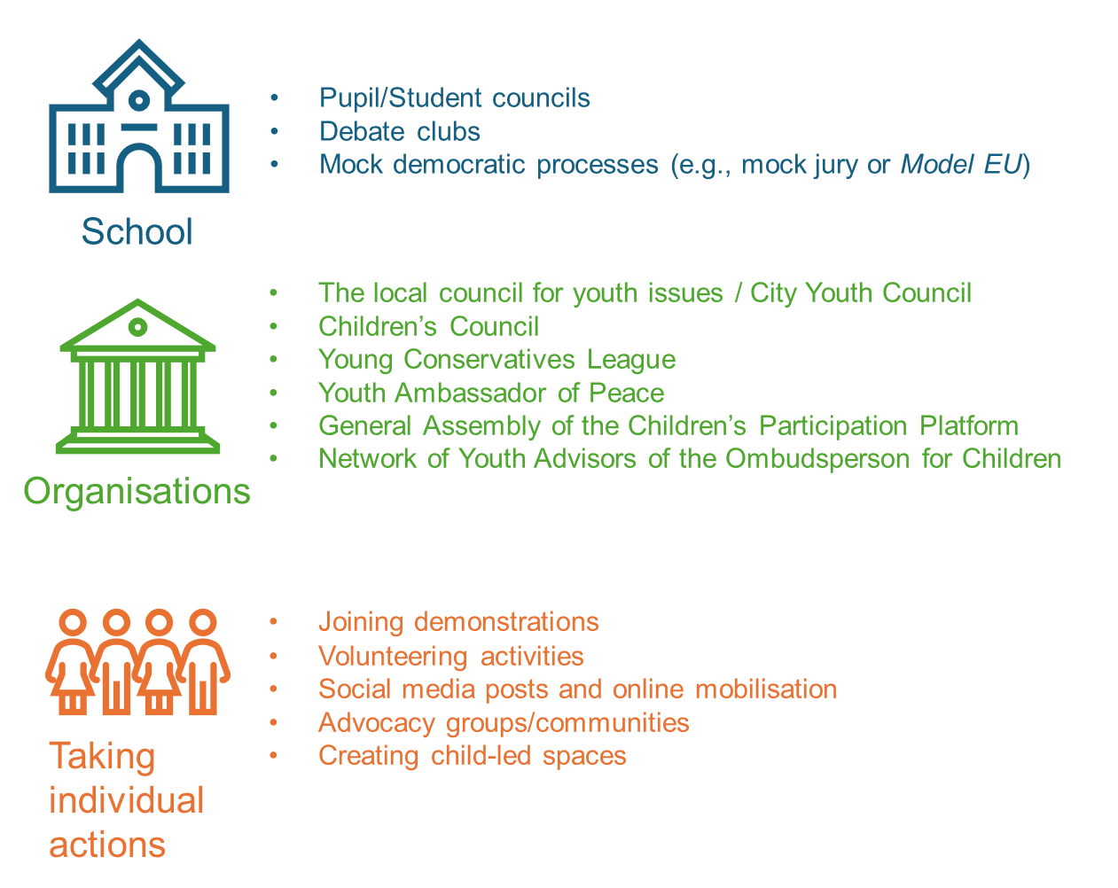

Some children said their democratic participation was limited to their households. Some children thought that democratic participation was more accessible through formal institutions, such as schools[17].

Some children took the initiative of creating participatory spaces if these were not readily available to them:

*‘There is no debate club in my city at the moment, but I am actively working on this issue to make it happen. When I lived in the city, I was a member of the debate club.’[18]*

## How do children participate and how would they want to participate

From our interviews, the democratic participation activities that children carried out in their schools included: (1) electing representatives, (2) discussing school issues affecting them (e.g. wearing uniforms, sports events), (3) writing petitions, (4) participating in mock activities like a mock jury or a mock meeting of the EU, and (5) voting proposals.

When children described the activities they took part in through larger organisations (like their City Council, the EU or Save the Children) they mentioned the following: (1) writing proposals with ideas on how to distribute funds or improve certain issues, (2) meeting members of the City Council and politicians, (3) writing letters to politicians, and (4) attending talks and group discussions.

*‘Often, children want to be heard, but they do not know how to do this and they try different methods. For example, I have expressed my views on Facebook because I was upset about an issue in school’ (15 years old[19])*

*‘We must be heard in different places, they must listen to us since we have the right to give our opinion’[20]*

On the available opportunities for children to participate in democratic processes, Local Youth Councils[21] and Student Councils[22] were the main institutions where children felt they could have their voices heard. This was followed by activities such as signed petitions[23], demonstrations/rallies[24], youth volunteering[25] and school debates[26].

In line with the interview findings, the survey highlights that almost 9 out of 10 (88%) children discussed their views with family members, 62% had participated in a voting at school, 59% had spoken with a teacher, and 43% had joined a school club. Other popular activities that children mentioned in the survey included: expressing their opinions online (44%), volunteering for an organisation (43%), giving their opinion in person by signing a petition or at a workshop (40%), and joining a community or online group (36%). The least popular activity among children was attending demonstrations (25%).

Have you ever shared your views in a democratic process on an issue that is important to you? N=1921

The survey results reflect that children’s preferences on participation mirrored those activities in which they already engaged. Children were especially keen on discussing with teachers/carers, joining an online/in-person club, and volunteering for an organisation. The least popular activity was also the one they do less often, i.e. joining demonstrations.

How would you like to participate? N=1690

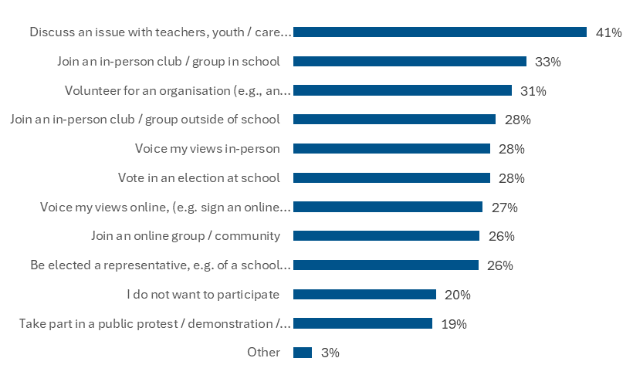

## Spaces created for and by children give them opportunities to influence decisions

Children taking part in the online survey said that groups and clubs created and run by children are places where they can mostly influence decisions. In addition, there were also positive about influencing decisions in organisations that advocate for children’s rights (52% and 39% respectively, cumulative figures for ‘somewhat’ and ‘a lot’ answers indicated by 4 and 5 stars respectively). Their schools and other online spaces were also mentioned as settings that they can influence. Conversely, more than half of surveyed children (58%) thought they had no influence at the national or international level. Overall, children were also less likely to think they had a strong influence on the work of Ombudsperson or at their local/regional government level.

How much do you think you can influence decisions in the following places? N=1897

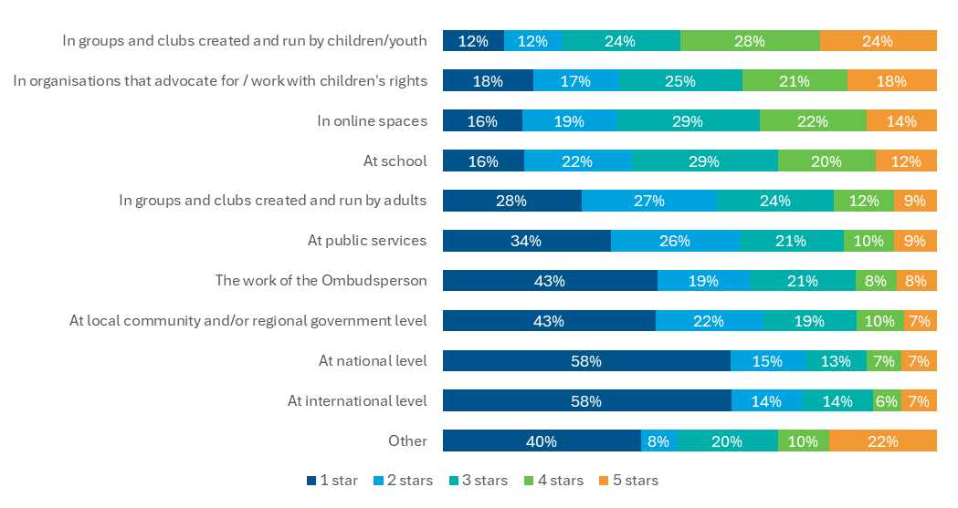

Note: 1 star = not at all, 2 stars = very little, 3 stars = neutral, 4 stars = somewhat, 5 stars = a lot

In terms of the spaces where they participate, children felt most comfortable in “safe-spaces” created for and by children, where they knew they could give their opinion and they would be heard and, most importantly, be taken seriously. However, **children do not want to only occupy spaces meant for them, they also want to take part in “adult spaces”** where the decision-making processes directly affect them. The pleas for "feeling heard” and respected were recurrent themes across countries and interviews.

*‘There is certainly no need to treat children and adolescents so childishly, as adults sometimes do’ (LT-FG-1)*

According to surveyed children, the factors that most supported children’s democratic participation included: (1) making participation inclusive and accessible (42% considered it very important), (2) being educated on children’s rights (41%), (3) having more opportunities to participate (40%), (4) more practical opportunities to learn about democracy (37%), and (5) more online written information on participation opportunities (35%).

Children acknowledged that it is difficult to take part in activities when these are not widely advertised. Consulted children suggested that child and youth organisations should receive more funding to outreach about activities and to increase the number and range of activities available. Children also asked to receive more information to be better informed on issues affecting them and how this would allow them to form their own opinions and defend their interests. Children thought they could benefit from child-friendly reports as much as from peer-to-peer training or role-modelling.

*‘For example, when they explain political issues to us, it does not interest us because of the way they explain it to us... I told the teacher that I didn´t like it and I didn´t understand it, that she should change the way she explained it, I could not find the connection with political issues’[27]*

*‘[A] peer-to-peer person who is a role model at school, for example. Or seeing other teenagers doing things and being exposed to serve as an inspiration. Also, through social networks. In short, teenage role models who know about the issues and can explain them to others.” (14 years old)*

## Children appreciate when their participation makes a difference

**Taking part makes children feel fulfilled and increases their confidence**

Children reported feeling positive and excited about their participation as it made them feel fulfilled and proud to contribute to society and “be a citizen”. Among surveyed children, 56% children expressed that participation made them happy, 55% felt respected, and 53% felt that they could freely explain their ideas and suggestions (cumulative answers for ‘agree’ and ‘strongly agree’ represented by 4 and 5 stars respectively) (see Figure 2.6).

During interviews and focus groups children explained that feeling heard increased their confidence to express opinions and gave them a sense of involvement, especially when taking part in large groups like the EU’s Children Participation Platform. Participation also facilitated development of soft skills such as leadership and inspired potential career paths.

*‘it feels good because you feel seen’[28]*

However, there was an even split between the children that thought that either their ideas were taken seriously (28% vs. 24%) and that adults would act on them (30% vs. 32%) or that they would influence change (32% vs. 39%), and those who did not.

How did you feel about your involvement? N=1679

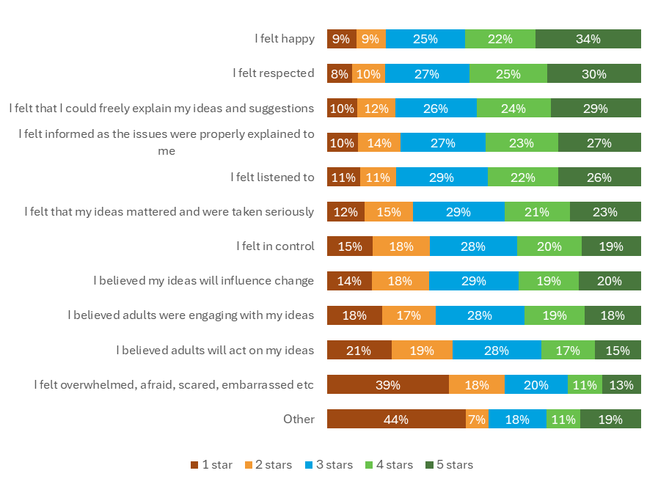

Note: 1 star = not at all, 2 stars = very little, 3 stars = neutral, 4 stars = somewhat, 5 stars = a lot

**Taking part can also lead to frustration when children’s ideas are not taken seriously**

A minority of participants reported negative feelings while participating, e.g. feeling nervous or fearing conflict between participants. Children more often reported negative feelings when thinking about demonstrations, which some described as “dangerous”. Among the surveyed children (see Figure 2.6) 13% said having felt very overwhelmed, afraid, or embarrassed.

During interviews children expressed feeling frustrated, especially when remembering instances when adults had not listened to them or had not taken their ideas seriously. Some children said their ideas were not respected or, even, judged by adults and peers. According to children, another source of frustration was realising that "change takes time” and they had to be “realistic” on what can be changed.

*‘every time a young girl goes out there and make her voice heard, there is a huge risk to be more judged’ (13 years old[29])*

*‘[Sometimes] they ignore our opinion simply for being young people... they use comments like you are not as mature as me... in my case, I never judge without knowing. You have to know what you are talking about and how you talk about it, you can't give your opinion on something you have no idea about, it wouldn't have much validity. We know a bit about everything, but as young people we don't tend to be ignorant’[30])*

*‘they listen more to adults because they think that adults know more’’[31]*

Across surveys, focus groups and interviews, children mentioned three key factors that increase their perception of influence: having an opportunity, being supported, and being heard.

During the online survey consultation, children expressed that learning how to approach adults who could bring about a change helped them to participate and influence decisions in the democratic processes (48%). Children also felt that knowing about the issue (47%) and adults listening to them (46%) helped them to participate and have influence on decisions made in the democratic processes. 18% of children did state that they don’t know what had motivated them to participate and to have influence on decisions in the democratic process.

What do you think has helped the most for you to have influence on decisions in democratic processes? N=1042

Children believed that it was important to have spaces where they can discuss issues affecting them. Hence, children highly valued having a student council or participating in activities organised through the City Council or similar governance organisations. Children positively assessed the involvement of adults in organising activities, motivating participants and dealings with conflicts.

*‘The best thing about the student’s council’s petition was how the teachers started to understand us, stand on our side and how our voices were finally heard’ (17 years old[32],*

Beyond having the space and support, children emphasised “feeling heard” as a crucial factor in them feeling able to influence decision-making processes. In this sense, children argued that adults must respect their ideas and welcome them with openness. Children argued that adults should take their ideas seriously because they provide a unique perspective that can be very valuable when designing policies affecting children. Children also emphasised that taking part in decision-making is one of children’s rights.

## Children’s recommendations

|  |
| --- |
| **Recommendations from children**  **Educate children about democratic values and processes**  Democratic participation requires education on democratic values and processes.  The school curricula and community engagement initiatives should include lessons on human rights, activism, as well as political participation.  There may be an advantage in being exposed – in a controlled setting – to role plays or simulations” of democratic and totalitarian regimes. This may help in better understanding and valuing democratic participation[33]  **Better inform children about democratic participation opportunities**  Participation activities as well as their outcomes should be more widely publicised.  Participation could be also encouraged by showcasing how to learn new things through participation.  **Involve children in more democratic participation activities**  Provide for more opportunities to be involved in democratic participation activities, including online platforms, discussion forums, mentorship programmes and community engagement initiatives.  Democratic participation opportunities should be delivered both in-person and online to offer children with flexibility to take part in them.  It might be easier for children to attend events taking place during school-hours.  **Involve children in child- and adult-focused spaces**  Enable being a part of spaces created for and by children but also in “adult spaces”, such as local councils, national parliaments or the European Parliament.  Decision makers ought to take children’s views into account across a range of decisions.  **Create safe and inclusive spaces for children to participate**  Create spaces where children and young people can express their opinions freely without fear of judgement.  Make children feel included and accepted, no matter of their age and background.  Provide support of adults and mentors to facilitate children’s participation in democratic decision-making.  Empower children by teaching participation methods. Involve children in the participation activities from early primary school age onwards as participation is a practice that must be learned from a young age. |

# Children care about and want to influence issues directly impacting them and society

Children across Member States are interested in taking part in and influencing the decision-making process of actions that will directly affect their lives or will have a consequence in society as a whole. Children are most often concerned about issues that directly impact their everyday lives, ranging from decision-making in relation to personal autonomy such as choosing what clothes they wear and school policies, to broader social and environmental matters. Children most commonly express a desire to influence decisions affecting their daily routines, school governance, and out of school activities in the community.

Children also expressed an interest in participating in democratic processes within their smaller communities (i.e. schools, local youth councils) as well as at national level through the right to vote. They also considered their participation to be relevant arguing that their voices were not being heard and represented by adults, leading to a sense of apathy about their ability to affect change.

## Children care about issues that have direct impact on their lives

T**he common denominator that links issues children care about is the idea that those issues directly impact them**. The extent to which this occurs is fairly consistent across countries, genders and age. The most common issues include:

1. **Personal autonomy and decision-making**. These issues affect children in every-day life, such as choices about their clothing and appearance, whereby children value making their own decisions about what they wear and how they look.[34] They also value having a say in school choices and career guidance.[35] Finally, children equally attached importance to decisions made in daily life and activities, including control over daily routines in the context of house rules, the food they eat, and household chores[36].

*“I would stand up for my own rights, but the line is thin between asserting my rights and respecting my foster mom” (Boy, 17, Hungary[37])*

1. **Having a say in the school environment and policies.** Children revealed a demand for influence in the decision-making processes of their school governance such as setting exam dates, having a say on the school’s activities and optional courses[38] and being able to vote and participate in student councils[39]. Moreover, they demonstrated interest in issues beyond the school’s curriculum such as the state of the school’s physical infrastructure[40]. Within the school environment, children also expressed interest in influencing the creation of anti-bullying measures.[41]

*“We really don’t get to have a say in anything at school. Whenever we are asked for our opinion, something else is done afterwards” (Child, 14, Germany[42])*

*It is important to let children my age speak and be heard. Sometimes adults see things in a different way and are not always right ‘ (16 years old, Denmark[43])*

1. **Demand for a provision of out-of-school leisure activities in local communities**, including a demand for better recreational facilities for children[44], as well as an expression of interest in participating in the planning of such local leisure activities[45].
2. **Concern for social and civic issues,** including concerns around racism, the problems faced by migrants due to racism and the need for increased awareness and education to combat it.[46] In addition, there is a need for broader emphasis on the importance of education about democracy, human rights, and civic responsibilities to allow children to become active and aware citizens[47]. Some children acknowledge that social media plays a role in exacerbating racism and bullying [SE-FG-1].

*“There is a lot of racism and bullying going on and the teachers don’t notice anything” (Student, Germany[48])*

1. **Geopolitical conflicts and national priorities**. Children from Spain and Germany considered that participating in a manifestation to support Palestine[49] was a useful way to express their views.
2. **Concerns around mental and physical health**, including the recognition of its importance, the need for accessible supportive services[50] together with good and affordable healthcare services and medications[51].

*“It is important that everyone has access to health services” (16 year old, Germany[52])*

1. **Awareness of economic inequalities** and disparities and their implications on the lives of children, their families, and communities[53]. Some children also expressed support for helping the homeless and creating more soup kitchens to help the less well-off[54].

*[the rich get richer, and the poor poorer] “It is how it is – I don’t know why” (13 year old, Germany[55])*

1. **Sustainability and climate change**. Some children showed strong concern for environmental issues and sustainability, expressing a desire to influence the solution-making processes[56].
2. **The rights and representation of children**, with special attention given to the need for national minorities to be represented fairly when decisions are taken, as well as gender equality[57]. Some children also generally expressed a demand for lowering the voting age from the standard 18 years of age to 16[58], though some children thought that children younger than 16 should also be able to vote[59] (see Section 5 for more information on children’s views on voting).

**Children fleeing the Russian war of aggression against Ukraine and democratic participation**

Discussion with children displaced from conflict zones and living in shelters highlight an important angle of the **democracy concept**. Consulted children from Ukrainian Roma communities (6 children in total) who used to live close to the Hungarian border before the war but were now living in shelters within Hungary had **mixed views on their power of influence**. Children need to **have their basic needs met**, such as safety and housing. For them, democratic participation was about bringing change to their residential houses to make them ‘homes’. For instance, they recalled the periodic residential assemblies where adults meet with social workers and the shelter’s director to address their concerns, and an opportunity to film videos for the shelter's director showing the things that they would want to change. One girl felt that she participated when adults agreed to her request to organise a birthday party for her. Overall, some children recognised that adults were addressing some requests mentioned during residential assemblies. However, there were also children thinking that speaking up was unlikely to bring up major change given their situation.

## Children want to influence decisions and make their voices heard

Nearly two thirds of the surveyed children (63%) wanted to influence decisions and help make children’s voice heard. Interestingly, 21% of children argued that it depends on other factors whether they wanted to influence decisions (see Figure 3.1).

Do you want to influence decisions and make children’s voices heard? N=1904

In addition, the majority of the children (70%) considered that main reason to participate was that the issue was important and they wanted to have a say (see Figure 3.2 below). The second and third most selected statement by the children was that an adult helped them to get involved after they shared their ideas with them (43%), and a friend or another child encouraged them to share their views (43%).

Please pick up to 3 things that have been important to you when deciding to participate in a democratic process. N=1726

Similarly, findings from the interviews and focus groups showed that children valued having their voices heard in decisions that affected their lives as well as the future of their generation[60]. For instance, interviewed children from Lithuania and Romania mentioned that their motivation to participate was based on the belief that being involved in democratic processes could improve their quality of life[61].

*‘We must be in all spaces where policies are designed that directly affect us, that in meetings are politicians/deputies discussing the laws but also that there are some boys and girls represented there.’ (15 years old, Spain[62])*

Results from the online survey consultation show that children expressed that learning how to approach adults who could bring about a change helped influence decisions in the democratic processes (48%). Children also felt that knowing about the issue (47%) and adults listening to them (46%) did influence them about decisions that were made. 18% of children surveyed did not know what had motivated them on decisions to participate in the democratic process.

Further, children from the Netherlands, Spain and Italy that were consulted in the interviews and focus groups considered participation in democratic processes as a fundamental right and a civil responsibility[63], arguing that children have the right to be involved in the decision making- processes that have a direct impact on their lives.

*‘Children also have rights to speak up and to give their opinions about things that matter to them.’* (*9 years old, The Netherlands[64])*

When surveyed children expressed that they do not want to influence decisions and make children’s voices heard, this was mostly because they were not interested in the democratic process (44%) and because they did not know how to be part of decisions (40%). Noteworthy, around one in four children did not believe that their participation will bring any change / make any difference (28%) or did not believe their voice, ideas and suggestions will matter to adults (26%) (see Figure 3.3 below).

Why didn’t you get involved in any of these democratic processes? N=1921

## Children would like to influence decisions but only one in four children have ever influenced any decisions

Children want to influence a diverse range of issues and problems affecting them. **The most common types of decisions that children want to influence are school policies and governance, daily routines and personal choices, and community and civic activities**.

However, **only one in four of the surveyed children indicated that they have ever influenced any decisions** (see Figure 3.4). Children felt they have had more influence on (a) laws and rules, (b) how money is spent and (c) raising awareness on specific issues. Have you ever influenced any of the types of decisions listed below? N=1619

It should be noted that **a significant number of respondents expressed a lack of awareness about the extent of the effectiveness of children involved in decision making processes**. As many as 38% respondents did not know if their ideas and suggestions have ever had any influence on any of the decisions listed in the survey, and 17% of respondents stated that their ideas and suggestions never had any influence on any of the decisions listed in the survey.

This potential lack of optimism is generally reflected in the data gathered at interviews and focus groups, whereby children have expressed a willingness or have actively tried to influence the decision-making process, but have experienced barriers to do so, including the feeling of not being heard. Surveyed children expressed an almost equal desire to influence almost all types of decision-making processes (see Figure 3.4), suggesting a strong desire to influence decisions made by adults.

How would you like to influence decisions made by adults (e.g. decisions of teachers, local officials, politicians etc.)? N=1921

Asked to rank actions they considered would help them become more involved in democratic processes, children who had not shared their views in a democratic process previously gave the highest score (4 and 5 stars) to: having someone explaining to them in person how to participate, having more opportunities to participate, and to teach children and adults about child rights and children’s right to participate.

What would help you become more involved in democratic processes and decisions in the future? N=519

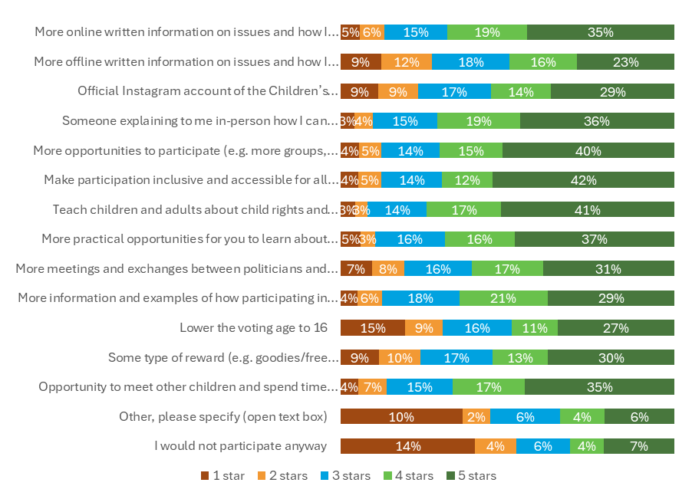

*Note: 1 star = not at all, 2 stars = very little, 3 stars = neutral, 4 stars = somewhat, 5 stars = a lot*

## Children’s recommendations

|  |
| --- |
| **Recommendations from children**  **Provide more opportunities for children to participate in democratic processes**  Encourage and facilitate more meaningful participation in decisions affecting their lives.  To increase motivation and engagement, adults should provide participation certificates, courses/trainings, and opportunities to travel.  **Reform governance and participation of children in schools and community programmes**  Allow children to influence school policies, exam dates, and anti-bullying measures.  Include children in planning local recreational activities and community infrastructure process.  **Create forums for social and civic issues**  Establish platforms for children to discuss and impact issues like racism, democracy, and community services.  Support the participation of children by reflecting on the importance of inviting children to participate as well as creating a safe space for them debate and present their ideas |

# Children are informed by social media, their peers and family

Being informed is a necessary condition for meaningful and inclusive democratic participation. It allows children to know where and how they can participate and make informed choices. Throughout the consultation, children emphasised the need to be informed in order to play a role in democratic processes[65].

## Children find information about issues they care about and learn about opportunities to participate from a variety of sources

Children find information about **issues** predominantly from their friends and family, their school, the news, and social media and the Internet. Children likewise learn about **opportunities** from these same sources - excluding the news.

Where do you get information about the issues you care about? N=1902

Some children mentioned that it is useful to look for information using **a combination of sources**. For example, one Lithuanian interviewee looks for information about issues *“mainly on social media, also, my mom shares this information with me. I always try to read different articles on topics that interest me. I also listen to the news.”*[66]

**Family and friends:** In total, 82% of children in the survey shared that they often got their information from speaking to family members and relatives and 68% of children had also favoured speaking to friends to get information (see Figure 4.1). Children participating in one of the focus groups in Spain stated that they speak to older family members who have lived longer and have more information and experience. However, the children recognised that this is not possible for all children as not everyone has an emotionally stable family[67]. In a focus group in Italy, children also expressed the value of having the opportunity to **discuss information** with their **peers** and adults[68]. **Likewise, friends**[69] **and family**[70] can share information about opportunities. Children who are already involved in youth organisations and city municipalities often share information with their peers about opportunities for children to participate[71].

**School:** For 47% of surveyed children (see Figure 4.1), school, teachers and educators are a good source to find information, and also to discuss it. Education settings and professionals were also mentioned in some focus group discussions with children[72].

**Schools can also help to share information about opportunities[73].** For example, in some schools the head of studies, guidance councillors[74], teachers[75] and teachers specialised in social/civic education[76] informed children. In other schools, the children reported that they are informed by *“News for children that we watch in school”*[77]. Schools can also have useful posters[78]. However, several children also specifically noted that their schools did not share information and this aspect should be improved.

Children can also use schools as a place to share information themselves, for example,

*“At the school of one of the [Spanish] participants they have a project of correspondents (the school students themselves) who organise dynamic activities to give information to other teenagers about resources for young people, activities, courses... This participant also mentions the PIJ (Youth Information Point).”* – (Spanish focus group)[79]

**Social media and the Internet** were one of the most cited methods for finding information and children see them as very valuable tools when used in an appropriate way. They are used in different ways, sometimes alongside other resources:

62% of surveyed children browse and read information online, and as noted in one of the focus groups, children access ‘*most of their information through the Internet and social networks*’[80]. Several groups of children said they seek information on topics that interest them using TikTok, Instagram[81] and YouTube[82]. Some groups mentioned this alongside using online newspapers[83].

39% of surveyed children follow issues / people on social media, for instance by following political parties, politicians and organisations[84].

Some children used social media as the first step to look for information before asking their peers and / or family[85].

*“Most of the information I find on the Internet, sometimes I talk to my family…”*[86] *(Lithuanian interviewee)*

The television, **Internet and social media[87]** were cited as a source for information on opportunities[88], including Snapchat, TikTok, Google and online newspapers[89].

Interestingly, avenues such as **reading newspapers, listening to the radio, and going to a local group** were least likely to be chosen as a method to get information about issues (see Figure 16). Notably, while **the news** does not appear to be a way of finding opportunities to participate, it is used as a way for children to inform themselves.

**Other sources of information** included attending training and presentations[90], talking to journalists[91], from their peers in the school council[92], organisations such as Save the Children[93], and by attending residential assemblies[94]. A younger child mentioned songs, television programmes and YouTube:

*“[…] when you create a song, television program or YouTube video, you can inform children on how to create a better world together*.” – (9 years old, the Netherlands[95])

**Community groups and local democratic structures** (e.g. local council for youth issues, attending meetings in local councils) were also noted by children as sources of information about opportunities[96].

Some children spoke about how **others inform them about opportunities to participate,** instead of having to search for the information and how ‘*getting invited by other people’*[97] could help them to participate.

*“Now everyone around me knows that I am active, so everyone shares with me various opportunities to participate somewhere (teachers, family members, acquaintances share information with me). […] Now I get a lot of information online – it seems to me that algorithms already know me well, I see a lot of information in my accounts about opportunities to participate, about issues that matter to me, and so on”.*[98]

## Children want more information about opportunities to participate

Children asked for more information about opportunities to participate and stated that this would help them to become more engaged and participate in democracy and decision-making[99]. Children also asked for information to be accessible and adapted to their ages; this will help them to give an informed opinion[100].

Suggestions included **more information about youth councils, organisations**[101] , **and municipal governments**[102]**;** and for **more information about what these organisations do and achieve**[103].

Several children **called for schools to play a greater role** in sharing information (both about structures within schools and about external opportunities)[104]. For example, in Romania a Student Council is a mandatory structure in each school, yet some of the consulted children were not aware of its existence and knew nothing about its activity[105]. Likewise, children consulted in Spain commented that there is not much information about participating on the school board[106].

*“I think there are many opportunities for children to participate, maybe not all of them are well publicised. Children should be better informed about all of these opportunities”*[107] *(*Child, Lithuania)

Information should also be **shared more widely.** Some children felt that information was not shared equally and called for equitable access to information and engagement opportunities to help facilitate active participation[108].

*“In my school, I do not know why it is this tradition, but just a few children know about opportunities in school and in the last moment, the others find out. It is not fair, we deserve to know at the same time.”* (Child, 17 years old, Romania).[109]

As summarised by a young adult interviewee:

*“I consider myself fortunate to have had opportunities from a young age, and the support of those around me has been crucial. However, challenges persist. One significant hurdle is the lack of awareness about events and groups**.” (Young adult, Croatia)*

## Children want to be informed about how they have influenced a decision

**Only half of children were informed about participation activities before taking part in them**

**Children value being informed about an activity before taking part.** Receiving information sufficiently in advance helps children to prepare and participate effectively[110]. This includes receiving information prior to deciding to take part in an event[111], knowing what will take place during the activity and what the objectives of the activity are[112].

Three in five of the surveyed children (61%) felt well informed about activities and its process by the organisers. However, only two in five surveyed children (45%) noted that the organisers made sure children were well informed about the topic of the activity and that they were provided with information before the activity (40%) (see Figure 4.2).

Were you well informed about the activities? N=1602

Children in the focus groups and interviews **overall seemed to have been properly informed prior to taking part in activities[113].** However, some children did not feel sufficiently informed, and their experiences of participation were negative as a result:

***“****Participants […] expressed dissatisfaction with the organisation of the process (election as class president or captain of the team in the sports club), because they did not receive the necessary information about the very function of these elections, whether the elected would have an impact to change something and what this position/function implies […]”[114]*

**Feedback matters to children after taking part**

Children **value receiving feedback**, knowing if and how their contributions made a difference[115] and having them acknowledged publicly. Raising awareness about the achievements made in spaces where children’s opinions are taken into account is important and will motivate children to continue to participate[116].

“*I like to participate in the [political youth organisation] because […] the organisation has its own communication team – it also works hard to communicate our activities publicly.”[117]*

Almost half of the surveyed children (49%) were informed about their influence on decision making by someone telling them what would happen going forward. However, a third of children stated they were not told how they would influence the decision, suggesting there needs to be consistency in the outcome of decision making to the children (see Figure 4.3).

Were you informed about how you would influence decision-making? N=1620

Children were aware of their impact and accomplishments when they saw a **concrete change** in the environment; children provided examples about changes they helped to accomplish in their accommodation, schools, sports teams, local communities and countries:

**Accommodation**:

“[…] a girl, who wanted to have a birthday party in the shelter […spoke to the shelter’s director…]. This was a special occasion, because it was the first time one of the girls stood up for their idea, and managed to organise it on her own. This gave courage to other children as well, and many birthday parties are planned in the near future.” (Hungarian focus group report)[118]

**Schools**:

“In the pupils’ council they had a campaign on football shirts to make the pupils respect each other’s teams. Everyone wore the shirt and it went very well. Now they can wear football shirts when they want at school.”[119]

“At the school they have many different nationalities so the pupils council arranged a “culture day” on which everyone would bring food from their culture, wear traditional clothes and dance. Now they will have this day every year due to the pupils council effort.”[120]

**Sports’ teams**:

"We promoted a sport that wasn't being played, there was no girls' volleyball and now there is a girls' team”.[121]

**National**:

“When I was a member of the Children’s Council, we made a film about the war in Ukraine, which was later broadcast on LRT (national television). One of the most accomplished things here, our position has been widely communicated.”[122]

*“Small achievements matter—they enhance our community’s quality of life”* *(*Young adult, Croatia)

**Not receiving feedback has negative impact on children’s engagement**

Many children expressed **disappointment**, saying that they do not expect to hear a reply or for their actions to make a difference. **Acknowledgement and feedback** would help to mitigate this and motivate children to continue getting involved[123].

*“Children should receive feedback on their actions and have an insight into this action”.* (Croatia, Group of children aged 14 to 17)[124].

Examples of children not receiving feedback or acknowledgement include when sending resolutions to local leaders (e.g.) mayors, their local councils, city councils, municipal governments, schools, and politicians.

*[Involved in a resolution as part of the [political youth organisation] on Vote16]. “That’s why we sent the resolution to the mayor […]. We gave it about a month ago, but we haven't received any response yet. Maybe that’s how it will end.”[125]*

*“I was a member of the Children’s Council and we discussed these important issues for me. In total, fifteen children from different cities of Lithuania participated. There have been 12 meetings in two years. We discussed the topics we discussed at our first meeting. For example, inclusive education, bullying, etc. Frequently came professionals with whom we could talk. We made our proposals, they were sent to municipalities, schools, institutions, and we wrote letters to politicians. However, we did not receive answers. It was only from elsewhere that we learned from time to time what, for example, some of our proposals were implemented in certain schools.”* [126]

As concluded and recommended by children in one of the Spanish focus groups, it is necessary to *‘reinforce the process of feed-back and accountability since the vast majority [of children]* *agreed that when they make proposals at the local level, to their City Council, they did not know in what state their proposals [were in] and whether they were going to be [implemented] or not.’*[127]Further, by acknowledging the children’s work and providing feedback, children felt that they will be motivated and other children will see the value of these groups. This was echoed by a young adult interviewee who reflected on what they would advise EU leaders and policy makers to help children become more involved.

*“[…] the most important is actually implementing in a way recommendations of youth. Because I think a lot of people enter some kind of processes with decision makers with a lot of hopes and you know, share their opinions and invest a lot of time in that and then they don't see that reflected in the final decision. So, I think the biggest aspect would be to actually find a way to meaningfully include youth so that they're not just invited, but that we're actually listened to in these events and that our recommendations are part of a final decision, whatever they may be.”* (Young adult, Croatia)

## Children are aware of misinformation and take precautions against it

Social media and the Internet are often children’s main source of information (see Section 4.1). In the digital age it is important that children and adults are media literate and able to analyse the information they receive. The topic of media literacy and the importance of being able to distinguish fake news was discussed in and enjoyed by some of the focus groups and interviews.

*“[Feedback…] the questions that they especially liked were those that focused specifically on democratic aspects and everything related to verifying the truth of the information they receive.”[128]* (Spanish focus group)

Evidence from consultations suggest that children **demonstrated an awareness and approach to combat misinformation** spread online. Children were aware of:

**Content feed-back loops / echo chambers promoted by online algorithms:**

*“They all agreed on that social media is not a great way to find information, since, for example, information on Facebook about children engagement in decision-making are usually recommended to people that already are interested in such things, so other people do not see this information.”[129]*

**Importance of using reliable sources, such as official organisations and institutions:**

*“I want to base my statements on facts, so I always try to look for information in reliable sources, for example, on the pages of Lithuanian institutions. However, it is often difficult to find something there, because not all of our state pages are well developed, constantly updated. Since I speak four languages fluently, I note that it is easier for me to find information in other languages than in Lithuanian.”[130]*

**The importance of avoiding spreading fake news**

*“[…] Nowadays, the flow of information is high, so it is necessary to carefully select reliable sources of information.”[131]*

*“In all the questions that revolved around contrasting the information, they expressed that they knew how to identify when a news item was insistently false and the importance of not spreading false news”* such as *“by (not) liking it without checking its veracity”* [132]

**Discussing information sources with other people, such as friends, members of their youth organisation, family and other adults**

*“We know if it is true by discussing it with the family, with the teachers, among people our age.”* (12 years old, Spain)[133]

*“I really enjoy talking with my friends about topics we hear at school or on social media. After we finish our classes, on our way to home, we share our perspectives and it is nice to see how different they can be.*”[134] (16 years old, Romania).

**Reviewing more than one source of information to make sure that information is true**[135] **while acknowledging that some children may not do it**[136].

*“We do not let ourselves be guided by the title (of the news), we compare the information”* (14 years old, Spain)[137]

Children interviewed in Spain *“[who] get information through social networks (above all using Tik Tok), or news from online newspapers… 100% of the group agrees on the importance and need to counteract the information that reaches them in order to be able to form their own opinion.”[138]*

Having **age appropriate and understandable information** helps children to understand the news and information they receive[139].

Some children also called for **adults to better tackle fake news.** Suggestions includedhaving roles dedicated to checking the veracity of information, and preventing fake news from being shared:

*“Adults need to do more to take away fake news […] Fake news that is shared by people, no one should be able to share fake news – there should be experts at Google that need to approve if it is true and then it should be able to stay online”[140]* :

Despite recognising the importance of checking multiple sources, some children expressed that **children often do not do this**.

“*[one type of media/one source of information in not enough to be informed] because what they say is not always true, you have to corroborate it, seek different opinions. Most people are too lazy to search for information because of the need for instant stimulation…”[141]*

In addition, among surveyed children, less than one in five stated that they would think why specific information that was sent to them, regardless of whether this was seen in an informative way or with confusion. Surveyed children occasionally questioned whether the person who wrote the information was honest (15%) and 4% of children said they did not reflect or check information they receive (see Figure 4.4).

If you receive information about issues and ways to take part, do you do any of the following? N=1921

Some consultation reports included references to children receiving misinformation (and not combating it).

*“[…] TikTok. They use this platform to get information about happenings in the world, and as a consequence, they receive much misinformation. On the other hand, they are able to communicate with their friends and family who stayed in Ukraine.”[142]*

## Children’s recommendations

|  |
| --- |
| **Recommendations from children (for adults)**  **Provide more information and better access to information**  Schools should play a greater role in sharing information about both internal (e.g. school council) and external opportunities to participate. This could be shared through guidance councillors, teachers, and posters.   * Schools should let children know about opportunities to participate in a fair way (and at the same time).   Children need information about opportunities to participate in youth councils, youth organisations and other opportunities to be disseminated more widely. This information should also include what these organisations have achieved.  Have more places where children can discuss information that they find, for example mentorship schemes and debate clubs.  **Provide information in a child-friendly way**  Make information accessible, age appropriate and easy to understand for children.  Official and trustworthy websites (e.g. governments) should try and provide accurate and greater information in languages of the EU-27.  **Provide more guidance about misinformation, and the skills and tools to take precautions against it**  More should be done to limit fake news and the ability to spread fake news.  Help raise awareness about misinformation and fake news.  Adults need to support in mitigating misinformation and gaining skills to combat it, e. g. by creating and using reliable sources, checking multiple sources, discussing information with other people).  **Acknowledge, take into account and share how children’s input influenced (or not) decisions**  Children want to know if proposals and actions have been received, whether any action will take place, and if action does take place, what are the expected results. Accountability measures should be set up to ensure children receive feedback, e.g. from schools, local governments, politicians.  **Recommendations from children (for children)**  **Share with your parents, teachers, educators and other adults that you are interested in democratic participation**  Tell the adults (e.g. parents, guidance councillors and teachers) and organisations for young people (e.g. local youth councils) around you about your interests.  Adults and organisations can help you find opportunities to participate.  Information about participation opportunities is also shared through social media.  Information about topics of interest can be found through a variety of means: by talking to friends, family and other adults, by reading the news, by following a mixture of people and topics on social media (e.g. politicians, organisations), by attending presentations, talking to organisations like Save the Children, attending local community meetings, reading books etc.  **Remember to check information**  It is good to use more than one source of information; this way you can find out if it is true or false.  It is also good to talk about information you find with adults and friends.  To avoid misinformation, use reliable sources, check multiple sources, and discuss information with other people. |

# Children want more education about voting

Voting in this Section means taking part in an election at local, national and EU-level. As such, while some consultations did discuss voting in schools, or in other gatherings, these findings are not discussed here.

Voting was generally a well-received topic and identified in feedback forms as an area that children are particularly interested in[143]. This section provides an indication of whether children believe the voting age should be lowered or not. However, since most evidence feeding into this section was of a qualitative nature, it is not possible to draw a quantitative conclusion regarding the share of children that were in favour or against lowering the voting age.

## Knowledge of voting

Voting is a relatively known topic to children and many consulted children were keen to discuss it. Children often identified voting[144] as a way of influencing the decision-making process[145]. At times, voting was seen as the *only* method of participation. For instance, in a Swedish focus group, children were asked in which democratic processes children can take part in. The answers included ‘I don’t know’ and ‘We cannot vote’[146].

However, this did not reflect the experience of all children. **Some ‘*had no concept of voting*** *and EU elections or why these are important’[147]* and others did not associate voting with democratic participation until prompted[148].

## Children expressed mixed views on whether the voting age be lowered

**Children’s voices in support of lowering the voting age**

In Austria, Belgium, Germany and Malta, the voting age is set at 16. In Greece, the voting age is set at 17. In the remaining EU Member States, the voting age is set at 18[149].

**In no less than twelve consultations** at least one person believed that the **voting age should be lowered.** Some of these involved just one child in a focus group or interview, others involved a majority of a focus group agreeing. As such, **it is not possible to calculate the exact share of children agreeing that voting age should be lowered, or the socio-demographic characteristics of children agreeing** (their age, gender etc.).

When children were in favour of a lowered voting age, suggestions ranged from age 10 at the youngest to aged 17 at the eldest. However, the most frequent suggestion was age 16, in line with many campaigns, such as the Vote16 resolution proposed by Lithuania’s City Youth Council[150] . Some children feel strongly about this and have actively participated in debates and movements to promote voting in their respective countries from the age of 16[151].

One group distinguished between the voting age in national elections and municipal elections, suggesting 16 for the former and 14 for the latter[152].

The survey results indicate that at least half of the respondents agree that children and young people should be allowed to vote in their respective country’s elections, and over a third replied that this will depend provided certain criteria or guarantees (see Figure 5.1 below).

Do you think children and young people should be allowed to vote in elections in your country? N=463

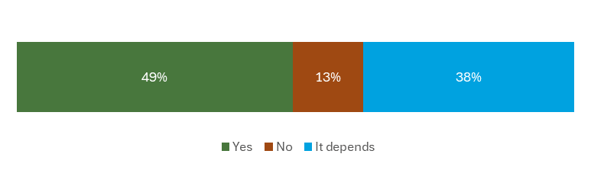

**Children gave a range of reasons for lowering the voting age**

A reoccurring theme was the idea that **children will one day be adults.** Children feel that they have a right to co-decide what occurs in their country and a right to participate in democracy[153]. Politicians need to take their opinions seriously. Additionally, by voting, children could contribute to policy-making, which is important as children make up a large part of society and their opinions are important for a properly functioning democracy[154].

Voting was seen as a way to **increase political representation** and **make politicians listen to children**. Children feel that if they could vote and thus contribute to policy-making, politicians would have to take children’s opinions seriously and listen to them[155].

Lowering the voting also has the potential to **increase active citizenship**. In Sweden, two interviewed children stated that allowing children to vote (from age 13) would help children to be more involved in democracy and decision-making[156]. Children were also aware of and highlighted studies which showed that when countries permit it ‘*voters under the age of eighteen are more likely to continue to vote in the elections in the future than those who started to cast their votes only after reaching the age of majority, because from a younger age they are more familiar with politics’[157].* The same interviewee also explained that by allowing 16-year old children to vote, they will be able to **contribute to policies in their area and become politically active before they relocate** to a larger city or even other countries:

*“In Lithuania, 16-year-olds make up a large proportion of young people. The trend is that, when they reach adulthood, the majority of young people go to larger cities or even other countries, and then they no longer have the opportunity to participate so actively and may not be so much interested in contributing to policy-making”[158] (*Lithuanian interviewee)

A young adult interviewee shared the view that a lowered voting age would increase active citizenship:

*“I am advocating quite strongly for the idea of lowering the voting age to 16. […] It's being done in some countries. […] It's good for building a democratic culture. It's proven in the countries that implemented this, that it helps because what research shows is that when you vote in your first elections, you tend to continue voting further in life, but when you get the right to vote at the age of 18, sometimes your first elections are at 21 or even 22 [...] very often at this age, people lose interest in voting, whereas when you start voting in high school […] The assumption is that it will make you more interested in voting, and then you will vote and continue voting throughout your life. […] I worked a lot with youth and it was always the best experience. They would always prove that they are really capable of participating and understanding the social issues.” (*Young adult, Croatia)

**Some children were conditionally in favour, provided they receive more education**

Children tended to agree that receiving education and information about voting and politics is a necessary step and condition to lower the voting age[159] and make informed decisions[160]. This idea occurred in at least six of the consultation reports.

*“More about politics […], about how a state is functioning, what exactly are the role of the state’s institutions, the government, parliament and the president. Moreover, they suggested to study about the EU starting with the age of 14-15.”[161]*

*‘Children need more education about democracy, about the workings of the state, about political parties, about how elections are run, about the European Union, NATO.[162]*

A majority of children said that this is the first step – when children will gain more knowledge on democratic processes they could start voting from 16 years old.

*"Children should not be able to vote until the public is well educated on these issues. We need to go deeper into these topics, we need to make it clear to children how these processes work."[163]*

Some children suggested 16 as the voting age, as it is at 16 that children learn more about the political system at school, and therefore have enough information to be able to become involved and vote[164]. **However, this is clearly not a universal experience, as the most common condition that children noted, was the requirement for education, prior to being granted voting rights.**

Essentially, **children recognised the need to be informed and educated to be able to vote, and desired more information to allow them to become active citizens**.

**Lower the voting age in some elections only**

Some children specified that the voting age should only be lowered some elections, e.g. regional / local, and once again added the condition that children should be informed about the process.

*“Regarding the possibility of children (regardless of voting age) to vote, they agree that children should vote, but only in some situations (…) and to be sure they are informed about this process. In addition to this idea, it would be useful to have a course during high school exclusively for democracy & voting. Two girls consider that children should not be allowed to vote. The local, European, presidential, parliamentary elections are serious matters, so it is a sensitive topic.”*[165]

*“Maybe each local community has different kinds of decisions that are related to children, like at smaller scales, for example, building a park here or there or something like that, and then to have children actually vote on it and discuss it and make a decision that could impact their environment.”* - Young adult, Croatia[166]

**Children provided a range of reasons for not lowering the voting age**

At least **eleven consultations** had at least one person who believed that the **voting age should not be lowered.** Notably, one child even suggested increasing the voting age.

*“I wouldn’t give 21-year-olds the right to vote because they aren’t mature enough.”[167]* (17 years old, Croatia)

**The lack of the maturity needed to vote** was a reoccurring reason provided by children for keeping the voting age at 18. For example, participants in a Croatian focus group ‘unanimously said that they would not allow children and young people to vote in elections in Croatia, because they feel they are not mature enough to vote’[168].Likewise, a child who participated in the Spanish focus group elaborated:

“*No (it [*the voting age*] shouldn’t be lowered) because those under 18 still do not know what it means to vote for a president, they do not have a sufficiently developed mind, they do not have enough maturity, […] children do not have critical thinking that developed yet, there are exceptions..."* (Child, 14 years old, Spain) [169]

Children from the same focus group agreed that before 18, one is not mature enough to vote. While they suggested the possibility of “*maturity testing”,* they accepted that this has limitations:

“*doing a maturity test that indicates whether they would be prepared to vote, they also accepted that it is very difficult to define “maturity to vote” and that perhaps such tests do not exist, in addition to understanding that each person is different, and a test does not include all the casuistic”*[170].

In a Croatian focus group, in addition to considering under 18s as generally not mature enough, children also pointed out that if required to vote*, ‘Children would be placed heavily responsible for the processes that will affect them, in a situation where they are not mature enough and do not have all the important information.’[171]*

**Education is an important factor for making informed democratic choices**

The views on the importance of education, training and awareness-raising were consistent among children whether they agree with a lowered voting age or not[172].

***“****I am not a huge supporter of this idea that children should be able to vote from the age of sixteen. I do not have a strong opinion, but I think that our society is not yet ready for it. I see that older students simply have no idea about these elections, about what is going on in politics – until society is well educated on these issues, children should not be able to vote. We need to take a closer look at these topics, and children need to be clearly told how these processes work. When an adult is not stuck, when he tells children openly and clearly, does not create an age barrier, I notice how everyone better focuses their attention, they are interested.”* – (Child, 16 years old, Lithuania)[173]

*“[Children who did not first mention voting when discussing ways to participate] Children were really interested in developing informative sessions about the process itself of voting and what are the next steps needed because they know that there are a lot of children who can be marked by a ballot or by a person collecting signatures on the street for a certain politician.”[174]*

As well as understanding and being able to make informed decisions about voting, children and young adults highlighted that education on political matters significantly contributes to overall participation.

*“I think that I am very privileged that I got a political education, even though it was non-formal. But I think it's a privilege to get a non-formal political education from a young age from high school and that's what enabled me and gave me the tools to understand and participate further…*

*… Education makes you more capable of participating, and therefore we need to implement civil education, political, and economic education in high schools, and ideally also elementary schools and that will make it easier for everyone to understand, even like on the most basic level of voting as well, and then also getting involved in organisations and councils and everything. (*Young adult, Croatia)

Reflecting on what they would advise EU leaders and policymakers to help children become more involved, one youth activist suggested:

*“I think first giving us access to more knowledge about this, so some form of citizen's education, I think it's very important from a young age and then building on top of that as you grow up through the education system […] I don't think we had a lot of access to that in Croatia in our education system. I had to learn most of what I know on my own. So, I think that's a really important step.” (*Young adult, Croatia)

Some children believed that children are **not sufficiently interested in politics** and could therefore **be influenced too easily** and harm the voting outcomes**,** such as by **voting for joke parties, for what their close friends believe in, and for what is perceived as ‘fashionable’.**

*‘Teenagers have no interest or reflection on politics in Spain. They feel that it is not something that affects their lives and they are not interested in it. They think that teenagers, as a joke, would vote for nonsense parties.’[175]*

‘*[They say don’t lower the voting age, as] although there are many teenagers with a critical sense, not all of them are interested in relevant issues and politics, and that this would harm the outcome because they would not vote for what they want but for what they are told by their close circle.’[176]*

Children also recognised the (at times harmful) influence of social media; children interviewed in Spain noted that under 18s may be more influenced by messages received on social networks as they are less mature and informed[177].

Often, children highlighted a **combination of the above factors** as a reason for not lowering the voting age. With a lack of education, information and training were often mentioned alongside aspects such as the potential to be overly influenced, lack of critical awareness and lack of interest.

*‘Regarding the voting age, they consider that it is well placed and that the important thing is to give information, understand the politics, which involves voting, what decisions can be made so as not to be influenced. It is not so much to focus on age as to generate a critical awareness and provide information about what it means to vote.’*[178]

*‘To raise awareness and avoid the risk of being influenced and manipulated, to train and inform them so that they become aware that voting allows them to decide on important issues that affect them and not to vote or act by “fashion”.’[179]*

*‘On whether boys and girls should vote. In general, they consider that age is well established and that training should be given since childhood to generate that awareness and avoid the risk of being influenced and manipulated [...] First you have to understand politics, which involves voting, what decisions can be made so as not to be influenced.’[180]*

Lastly, a Croatian focus group also suggested that children were uninformed, and liable to be influenced by populist messages.

*“Most children are not informed enough to vote. Most children are uninformed, and it is not good to vote uninformed and influenced by “cheap” populist messages and people present in our society.”* ***[181]***

*“Most people and young people are not relevant[ly] enough informed in general, let alone at the age of 16!”**[182]*

## Children expressed a willingness to vote if the voting age was lowered

Children who were in favour of lowering the voting age would vote if they could. Children who disagreed with lowering the voting age, were often willing to vote. However, both groups emphasised the need for more information and education and more encouragement to become engaged in democratic matters.

*“I don’t really follow politics.”’* (Child, 14 years old, Denmark)[183]

In terms of national priorities, children from Lithuania, Romania and Spain, that participated in the interviews and focus groups, expressed an interest in being able to vote in the national elections[184].

When discussing the ability to vote as (young) adults, some children were in favour of **sanctioning adults who fail to vote**[185]**,** whereas other children suggested more subtle methods. These included more encouragement and support[186], organising training groups or public debates where adolescents and adults can form their own opinion and learn to use participatory tools/channels to become more confident around voting[187], and encouragement by increasing representation of specific types of voters (such as young people)[188]:

*‘Children and young people would give a voice to a person with whom they can connect, who is closer to them by age and is a real person they are following for other activities. It is important that candidates represent their representation (by age and gender), because if they are not represented (e.g. that there are more women on the list), they are not motivated to vote.’[189]*

*As they do not follow political developments and if some information were to be reached (children and young people) this would need to be done via the digital networks they follow (the example of TikTok).[190]*

The survey results support these findings. Children we asked if they would vote if children in their country were allowed to do so, with the majority responding: *’Yes, definitely’.*

If children could vote in your country, would you vote? N= 465

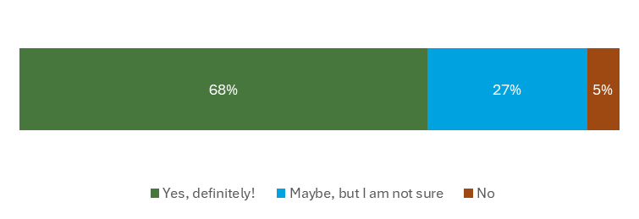

## Children’s recommendations

|  |
| --- |
| **Recommendations from children (for adults)**  Politicians should listen to children (more).  Children’s voices should be better represented.   * There should be more education about voting (e.g. from age 14 through formal and informal education and training). Information should include: democracy, how democratic institutions work, democratic processes within government and beyond, the roles and responsibilities of various bodies and individuals, e.g. the president and / or prime minister, the government, the national parliament, the EU, political parties, NATO etc. |

# Children’s priorities

|  |
| --- |
| **Key recommendations from children**  Educate children and adults about democratic values, democratic and political participation and about the value of children’s participation.  Provide children with more information about voting and democratic institutions and processes.  Encourage children to take part by showcasing how they can personally benefit from democratic participation as participation is a practice that must be learned from a young age.  Inform children about democratic participation opportunities, and with practical information on how, when and where they can take part.  When sharing information, ensure that it is provided in an accessible, inclusive, age-appropriate and understandable way.  Create more safe and inclusive spaces for children to participate and express their opinions freely without fear of judgement.   * + Support children’s participation in spaces created for and by children.   + Reform governance and participation of children in schools and community spaces to allow children to influence school policies and measures.   + Create more forums for exchanges on social and civic issues and better facilitate opportunities for children to participate in ‘adult spaces’.   Ensure accountability to children.   * + Ensure children receive feedback.   + Share with children the impact (or lack of) their participation.   Provide children and adults with more guidance about misinformation.  Actively address misinformation by creating reliable sources of information and raising awareness.  Equip adults and children in the skills and tools to effectively take precautions against misinformation. |

1. Consultation methodology and characteristics of children participating in the consultation activities
   1. Consultation methodology

Consultation design

Children’s contribution to EU-level consultation addresses the first objective of the Platform ‘to gather the views of and to consult children, across several EU Member States, on matters that concern them, including on future specific policy and legislative initiatives.’

The Platform consultations were designed to provide a meaningful, inclusive and safe space for children to share their ideas. The Platform’s consultations are implemented via online surveys, and online and in-person focus groups and interviews.

All consultations were guided by the Lundy model[191].

The design of the consultation process and the consultation materials, topic and features were co-created with children at the Children’s Panel. The consultation questions involved discussion points that the children considered important for the consultation topic. The survey questionnaire was also adapted from a Safe the Children survey on civil and political rights. However, child participation experts, Laura Lundy and Cath Larkins were also instrumental in designing questions (included in the data collection tools, such as a survey questionnaire and interview and focus group topic guides) that would be appropriate for children.

Child Empowerment Officers (CEOs) and Central Office Colleagues from Save the Children and SOS Children’s Villages, experts in child participation, also contributed to designing the questions and the consultation process. The CEOs had an active role in shaping children’s participation to ensure it is aligned with their expectations and level of understanding. The topic guides provided suggestions on how to conduct interviews and focus group discussions, however, they could be implemented up to the discretion of the facilitating CEO/other personnel. This meant that, while maintaining the high standards, all the consultations were appropriate and dependant on the background of the children, age, and group size.

All facilitators of interviews and focus groups shared reports from their discussions with children. These reports, together with the online survey data, were systematically analysed and synthesised in an analytical report by the Platform Secretariat staff from RPA and ICF.

All children were briefed on how their input would be recorded and feed into the development of policy materials at EU-level.

Outreach & recruitment

The CEOs, Central Office Colleagues and Secretariat all shared and promoted the survey online, on social media, the Platform’s website and newsletter, the European Commission Rights of the Child’s newsletter and the EAC/EU Youth Portal website and their Instagram channel. Through the Platform outreach, schools in Romania and an office of an Ombudsperson for Children in Croatia widely disseminated the survey among their students and subscribers, accounting for the high percentage of Romanian and Croatian respondents.

Outreach for the focus groups and interviews involved contacting all organisations and children who had expressed an interest in participating in focus groups and interviews. Furthermore, all those organisations mentioned above were also contacted and informed on the possibility to conduct their own consultations.

The CEOs promoted a diverse and representative response to the survey and attendance of focus groups and interviews by diffusing the information, sign-up etc to underrepresented groups of children.

Challenges and limitations

This second consultation conducted as part of the EU Children’s Participation Platform built on the experiences of the first consultation, addressing the challenges and limitations encountered. While the survey was again hosted on EU Survey, the child-friendliness and of the design and translations were improved. The theme was selected by children who took part in the EU Children’s Participation Platform activities in 2023[192].

* 1. The consultation in numbers

In total, 2,071 children and some young people participated in the consultation activities, including 1921 children providing valid responses in the online survey, 28 children and 3 youth activists participating in the interviews and 122 children participating across 19 focus groups[193]. Table 1 provides a break down for each consultation format.

* + - * 1. Table 1 The consultation in numbers

| Criterion | Survey | Focus groups | Interviews |
| --- | --- | --- | --- |
| Number of participating children | Total number of responses: 2658.  1921 valid responses included in the analysis | 122 children in 19 focus groups | 28 children and 3 youth activists |
| Location | 23 EU Member States (apart from Austria, Estonia, Finland, and Slovenia). | 9 EU Member States (Croatia, Germany, Hungary, Italy, Lithuania, the Netherlands, Romania, Spain, Sweden) | 8 EU Member States (Croatia, Denmark, Italy, the Netherlands, Lithuania, Romania, Spain, Sweden) |

* 1. Characteristics of survey respondents

Total number of valid responses to the survey: 1921

**Respondent by country:**

|  |  |  |
| --- | --- | --- |
| **Country** | **N** | **%** |
| Romania | 1161 | 60% |
| Croatia | 370 | 19% |
| Ireland | 83 | 4% |
| Lithuania | 73 | 4% |
| Poland | 35 | 2% |
| Italy | 31 | 2% |
| Spain | 31 | 2% |
| Sweden | 21 | 1% |
| France | 19 | 1% |
| Germany | 19 | 1% |
| Hungary | 13 | 1% |
| Cyprus | 12 | 1% |
| Bulgaria | 11 | 1% |
| Netherlands | 11 | 1% |
| Portugal | 7 | <1% |
| Greece | 4 | <1% |
| Belgium | 3 | <1% |
| Denmark | 3 | <1% |
| Latvia | 2 | <1% |
| Czechia | 1 | <1% |
| Luxembourg | 1 | <1% |
| Malta | 1 | <1% |
| Slovakia | 1 | <1% |
| I'm an EU citizen living abroad | 8 | <1% |

**Age**

**Disability**

**Identity groups**

**Gender**

|  |  |  |
| --- | --- | --- |
| **Gender** | **N** | **%** |
| Boy | 741 | 39% |
| Girl | 1104 | 57% |
| I don’t want to say | 45 | 2% |
| Other | 31 | 2% |

* 1. Characteristics of children participating in focus groups and interviews

**Focus groups**

|  |  |  |  |  |  |
| --- | --- | --- | --- | --- | --- |
| **Country** | **N of focus groups** | **N of children** | **Gender** | | **Age** |
| **Girl** | **Boy** |
| Croatia | 2 | 15 | 12 | 3 | 14 to 17 |
| Germany | 1 | 3 | 1 | 2 | 13 to 16 |
| Hungary | 2 | 12 | 2 | 10 | 10 to 13,  16 to 17 |
| Italy | 2 | 21 | 12 | 9 | 6 to 10,  15 to 17 |
| Lithuania | 1 | 10 | 6 | 4 | 15 to 17 |
| The Netherlands | 1 | 7 | 6 | 1 | 15 to 17 |
| Romania | 4 | 16 | 14 | 2 | 15 to 17 |
| Spain | 4 | 30 | 21 | 9 | 12 to 15,  13 to 17 |
| Sweden | 2 | 8 | 5 | 3 | 10 to 13 |
| **Total** | **19** | **122** | **79** | **43** | **6 to 17** |

**Interviews**

|  |  |  |  |  |
| --- | --- | --- | --- | --- |
| **Country** | **N of children** | **Gender** | | **Age** |
| **Girl** | **Boy** |
| Croatia | 2 | 1 | 1 | 16 to 17 |
| Denmark | 1 |  | 1 | 14 |
| Italy | 4 | 3 | 1 | 15 to 16 |
| Lithuania | 3 | 2 | 1 | 16 |
| The Netherlands | 4 | 2 | 2 | 7 to 16 |
| Romania | 6 | 6 |  | 13 to 17 |
| Spain | 6 | 3 | 3 | 12 to 14,  15 to 16 |
| Sweden | 2 |  | 2 | 11 to 13 |
| **Total** | **28** | **17** | **11** | **11 to 17** |

In addition, there were 3 interviews with youth activists (aged 18, 21 and 24) from Croatia

1. In total, 2,071 children (aged 6 to 17) and 3 youth activists (aged 18 to 24) participated in the consultation activities. Youth activists took part in the interviews. In total, 60% of the survey respondents were from Romania and another 19% from Croatia.
2. <https://commission.europa.eu/system/files/2022-12/lundy_model_of_participation_0.pdf>
3. The [EU Children’s Participation Platform](https://eu-for-children.europa.eu/feeling-safe) aims to strengthen children’s rights and participation across the EU. One of the ways the Platform promises to achieve this is through direct consultation with children.
4. In total, 2,071 children (aged 6 to 17) and 3 youth activists (aged 18 to 24) participated in the consultation activities. Youth activists took part in the interviews.
5. Disclaimer: This document should be regarded solely as a summary of the contributions made by children to the consultation on democracy and voting. Responses to the consultation activities cannot be considered as a representative sample of the views of the EU population. It has to be noted that 60% of the survey respondents were from Romania and another 19% from Croatia.
6. NL-INT-1. Please note that all consultation material is coded using the following convention: official country code, followed by ‘FG’ to represent focus groups or ‘INT’ to represent interviews, and a number indicating a specific focus group or interview.
7. ES-FG-2
8. NL-INT-1
9. ES-FG-1
10. ES-FG-3
11. ES-INT-1
12. ES-FG-4
13. HR-FG-1 and HR-INT-1
14. SE-FG-1, SE-FG-2, SE-INT-1, SE-INT-2
15. IT-FG-1 and IT-FC-2
16. LT-INT-1
17. IT-FG-1 and IT-FC-2
18. LT-INT-1
19. RO-FG
20. ES-FG-1
21. LT-INT-1, RO-FG-1, RO-FG-2, RO-FG-3, RO-FG-4, RO-INT-2, RO-INT-3, RO-INT-4
22. DK-INT-1, HR-FG-1, HR-INT-1, LT-INT-1 and SE-INT-2,
23. RO-INT-1
24. DK-INT-1 and ES-INT-1,
25. ES-INT-1 and LT-INT-1
26. ES-FG-3 and LT-INT-1
27. ES-INT-1
28. DK-INT1
29. RO-INT-1
30. ES-INT-2
31. SE-FG-1, SE-FG-2, SE-INT-1, SE-INT-2
32. HU-FG-1
33. LT-INT-1, IT-FG-1 and IT-FC-2
34. HU-FG-1
35. HU-FG-1
36. HU-FG-1, RO-INT-1
37. HU-FG-1
38. DK-INT-1, RO-INT-1 and NL-INT-1
39. RO-FG-1, RO-FG-2, RO-FG-3, RO-FG-4, RO-INT-2, RO-INT-3 and RO-INT-4
40. HU-FG-2
41. HU-FG-2
42. DE-FG-1
43. DK-INT-1
44. LT-FG-1] [HU-FG-2
45. ES-FG-1
46. ES-INT-1 and ES-INT-2
47. HR-INT-1, HR-FG-, IT-INT-1, IT-FG-1, IT-FG-2, LT-INT-1, NL-INT-1, NL-FG-1and RO-INT-1
48. DE-FG-1
49. DK-INT-1 and ES-FG-3
50. LT-FG-1
51. SE-FG-1, ES-INT-1 and LT-FG-1
52. DE-FG-1
53. SE-FG-1
54. ES-FG-3
55. DE-FG-1
56. LT-INT-1, SE-FG-1
57. LT-FG-1, LT-INT-1
58. LT-FG-1
59. RO-INT-1
60. DK-INT-1, ES-FG-1, ES-FG-3, HR-FG-2, HU-FG-1, HU-FG-2, IT-INT-1, LT-FG-1, LT-INT-1, NL-INT-1, NL-FG-1, RO-FG-1, RO-FG-2, RO-FG-3, RO-FG-4, RO-INT-1, RO-INT-2, RO-INT-3 and RO-INT-4, SE-INT-1 and SE-INT-2
61. LT-INT-1 and RO-INT-1
62. ES-FG-2
63. ES-FG-1, IT-INT-1 and NL-INT-1
64. NL-INT-1
65. IT-FG-1 and IT-FG-2.
66. LT-INT-1: Interviewee 3.
67. ES-FG-1.
68. IT-FG-1.
69. RO-FG-1 / RO-FG-2 / RO-FG-3 / RO-FG-4 / RO-INT-2, RO-INT-3, RO-INT-4.
70. NL-INT-1.
71. LT-FG-1.
72. SE-FG-1.
73. NL-FG-1.
74. ES-FG-2.
75. LT-FG-1
76. RO-FG-1 / RO-FG-2 / RO-FG-3 / RO-FG-4 / RO-INT-2, RO-INT-3, RO-INT-4.
77. SE-FG1 and SE-FG-2.
78. RO-FG-1 / RO-FG-2 / RO-FG-3 / RO-FG-4 / RO-INT-2, RO-INT-3, RO-INT-4.
79. ES-FG-3
80. HR-FG-2.
81. ES-INT-2
82. SE-FG1, SE-FG2, SE-INT 1 AND SE-INT 2
83. ES-INT-1
84. LT-INT-1.
85. HR-FG-1 and HR-INT-1.
86. LT-INT-1 (Interviewee 3).
87. See Section 4.4. ‘Children are aware of misinformation and some children combat it’ for more detail regarding safe participation.
88. LT-INT-1, RO-FG-1 / RO-FG-2 / RO-FG-3 / RO-FG-4 / RO-INT-2, RO-INT-3, RO-INT-4 and, NL-FG-1.
89. SE-FG-1, SE-FG-2, and NL-INT-1.
90. LT-INT-1: Interviewee 3
91. RO-FG-1 / RO-FG-2 / RO-FG-3 / RO-FG-4 / RO-INT-2, RO-INT-3, RO-INT-4
92. ES-FG-2
93. SE-FG-2.
94. HU-FG-2.
95. NL-INT-1
96. RO-FG-1 / RO-FG-2 / RO-FG-3 / RO-FG-4 / RO-INT-2, RO-INT-3, RO-INT-4.
97. LT-FG-1.
98. LT-INT-1.
99. DK-INT-1.
100. ES-FG-2.
101. LT-FG-1 and LT-INT-1.
102. ES-FG-2.
103. ES-FG-3, ES-FG-2 and HR-FG-2.
104. ES-FG-2.
105. RO-FG-1 / RO-FG-2 / RO-FG-3 / RO-FG-4 / RO-INT-2, RO-INT-3, RO-INT-4.
106. ES-FG-2.
107. LT-INT-1 Interviewee 1.
108. IT-INT-1.
109. RO-FG-1 / RO-FG-2 / RO-FG-3 / RO-FG-4 / RO-INT-2, RO-INT-3, RO-INT-4.
110. NL-FG-1.
111. RO-INT-1.
112. ES-FG-3.
113. LT-INT-1, Interviewee 3; RO-INT-1.
114. HR-FG-1 and HR-INT-1
115. HR-FG-2.
116. ES-INT-1
117. LT-INT-1
118. HU-FG-2
119. DK-INT-1
120. DK-INT-1
121. ES-INT-2
122. LT-INT-1
123. DK-INT-1, LT-INT-1 and ES-FG-2.
124. HR-FG-2
125. LT-INT-1
126. LT-INT-1
127. ES-FG-2.
128. ES-FG-1
129. LT-FG-1
130. LT-INT-1
131. LT-INT-2
132. ES-FG-1
133. ES-FG-1
134. RO-FG-1 / RO-FG-2 / RO-FG-3 / RO-FG-4 / RO-INT-2, RO-INT-3, RO-INT-4
135. HR-FG-2.
136. DK-INT-1.
137. ES-FG-1
138. ES-INT-1
139. HR-FG-2
140. SE-INT-1 and SE-INT-2
141. ES-FG-1
142. HU-FG-2
143. SE-INT-1 and SE-INT-2 (Ages 12,13), HR-FG-2 (Ages 14-17).
144. HU-FG-1.
145. IT-FG-1, IT-FG-2. ES-FG-1 (Ages 12-15).
146. SE-FG-1 (Ages 10-13).
147. HU-FG-2.
148. RO-FG-1 / RO-FG-2 / RO-FG-3 / RO-FG-4 / RO-INT-2, RO-INT-3, RO-INT-4.
149. See https://www.europarl.europa.eu/RegData/etudes/ATAG/2023/749767/EPRS_ATA(2023)749767_EN.pdf
150. LT-INT-1.
151. LT-INT-1.
152. LT-FG-1.
153. NL-INT-1.
154. LT-INT-1: Interviewee 2andLT-FG-1 (Ages 15-18)*.*
155. LT-FG-1 (Ages 15-18) and LT-INT-1.
156. SE-Int-1 and SE-int-2 (Ages 11-13).
157. LT-INT-1.
158. LT-INT-1.
159. NL-FG-1.
160. LT-FG-1 (Ages 15-18)*.*
161. RO-INT-1.
162. LT-FG-1. (Ages 15-18)
163. LT-FG-1 (Ages 15-18).
164. NL-INT-1 *“[lower the voting age to 16] because I think that children need to co-decide about what happens in their country. And at 16 years old children learn more about the political system at school, so they get enough information to be more involved and vote”*. – Boy, 16 years old, the Netherlands.
165. RO-FG-1 / RO-FG-2 / RO-FG-3 / RO-FG-4 / RO-INT-2, RO-INT-3, RO-INT-4.
166. This interviewee was in favour of lowering the voting age, however provided alternatives.
167. HR-FG-1 / HR-INT-1.
168. HR-FG-1.
169. ES-FG-1.
170. ES-FG-1.
171. HR-FG-2: (all, Ages 14-17).
172. ES-INT-2 (Ages 15+16).
173. LT-INT-1.
174. RO-FG-1 / RO-FG-2 / RO-FG-3 / RO-FG-4 / RO-INT-2, RO-INT-3, RO-INT-4.
175. ES-FG-3 (Ages 14-15).
176. ES-FG-5 (Ages 15-17).
177. ES-INT-2 (Ages 15 and 16).
178. ES-FG-2 (Ages 13-17).
179. ES-FG-2 (Ages 13-17).
180. ES-FG-2 (Ages 13-17).
181. HR-FG-2 (all, Ages 14-17).
182. HR-FG-2 (all, Ages 14-17).
183. DK-INT-1: Aged 14.
184. ES-INT-2, LT-INT-1, RO-FG-1, RO-FG-2, RO-FG-3, RO-FG-4, RO-INT-2, RO-INT-3 and RO-INT-4
185. HR-FG-2.
186. LT-INT-1*.*
187. ES-FG1.
188. HR-FG-2 (all, Ages 14-17).
189. HR-FG-2
190. HR-FG-2
191. <https://commission.europa.eu/system/files/2022-12/lundy_model_of_participation_0.pdf>
192. Some feedback to Consultation 2 indicated that theme of the consultation was too narrow and not relevant for children who come from underrepresented/underprivileged backgrounds and there are more *“important levels for them before reaching self-actualization, which contains standing up for themselves and their rights or asserting rights of others. The topic of democracy and elections are too distant, vague and difficult to comprehend for someone, who is a victim of system abuse. […] That’s the reason why the consultation questions were changed and adapted to the special needs of our target groups”.* (HU-FG-1 and HU-FG-2) However, the CEOs are experts in child participation and were able to adapt the consultation guides so that the children participating benefit from and engage with the consultation.
193. Disclaimer: This document should be regarded solely as a summary of the contributions made by children to the consultation on democracy and voting. Responses to the consultation activities cannot be considered as a representative sample of the views of the EU population. It has to be noted that 60% of the survey respondents were from Romania and another 19% from Croatia.